## Hotspot Tool Specification

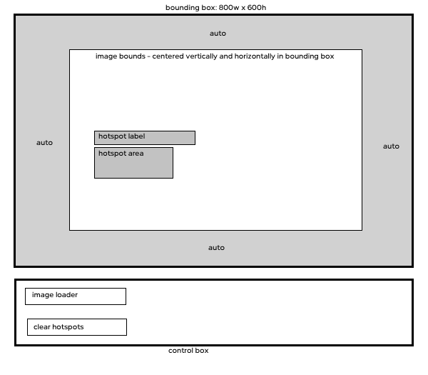

The tool will have 2 main areas: the hotspot placer and the control box.

## Hotspot placer

* The max size for an image will be 800x600. If it is less than this, the image is to be centered in the bounding area. If it is larger than this, the top left of the image is to align to the top left of the bounds.
* The area of a hotspot will be defined by two points: the first point is where the mousedown event occurs, and the second is where the mouseup event occurs. The x/y value of the area will be whatever point is at the top-left. Generally this will be the mousedown event, but not necessarily.
* As the user drags the mouse after mousedown, a faint rectangle will be drawn between the mousedown location and the cursor location
* On mouseup, the hotspot will be created.
  + The hotspot will have the same area as the above drawn rectangle.
  + The hotspot will have a label which by default will appear at the top left of the hotspot, as per the drawing. If the label would lie outside the bounds (not just outside the image), then the label is to be moved inside the bounds.
  + The text in the label is to be in the following format: x=”” y=”” width=”” height=””.
  + The text in the label must be selectable. Ideally onclick all text in the label will be selected for quicker copying.
  + The created hotspot is to be draggable.
    - On mouseup, if the hotspot is inside the area of the image, the x/y coordinates in the label are to be updated
    - If the hotspot is outside the image area, it is to be deleted.
    - If the hotspot is released within 5 pixels outside the image, it is to be placed inside the image at the closest location to the drop point.
* Hotspots can only be drawn inside the image.
  + If the mousedown event occurs outside of the image, nothing happens
  + If the mouse down event is inside the image, but the rectangle is drawn outside of the image, the rectangle is to stop at the edge of the image. This will not cause the drawing event to end, just the edge of the hotspot. The main purpose for this is the placement of hotspots close to the edge of the image.

## Control Box

* The control box has two main functions: to load images and to clear all hotspots
  + Clear all hotspots – onclick, all hotspots are to be deleted.
  + Image loading
    - On click, the file open dialog will be launched.
    - If possible, this dialog is to point to the last location used
    - Selecting a file will load the image and clear all existing hotspots